**Name: Robanpreet singh**

**ID: 3157655**

**Title: Canteen Management**

**Call Discussion with Client: Jatin**

**Information of the client: Jatin Runs his Canteen where sale different type of products to his customers and he is now facing problem of maintain all this stuff manually and decided to move digitally .**

Client Name – Jatin

Business- Canteen

Contact details: +64 541 5452 655

Address : Queen st. Road Papatoetoe, Auckland

The Primary objective is to move the data to digital platform for easy access and increase the growth and margin of his business as with the help of digitalization Jatin will save his lot of time and also record will be always correct and on time moreover he can have holidays also as some of his employee can enter the data on the software

**Task 2 - Define and document requirements**

Requirement of The Software

Scope of Work

**Features:**

Jatin is looking for website having secure pages that should open without loading and structure of website should be simple easy so that anyone can easily use this website

**Functional Requirements:**

Proper Error Handling

Should not lack at any point

Pages should be interlinked between each and other

Update and delete function should work where appreciate

**Non-functional requirements:**

SEO Friendly

Should be open properly on every Mobile Phone

Should be open on Tablet also Properly

Text should be easily readable

Time: It will take minimum 20 days to complete.

|  |  |
| --- | --- |
| Planning | 03 days |
| Requirement Gathering | 05 days |
| Designing | 02 days |
| Development | 8 days |
| Testing and Implementation | 4 days |

**The 4 essential steps of the Risk Management Process are:**

1. **Identify the risk**: The four main risk categories of risk are hazard risks, such as fires or injuries; operational risks, including turnover and supplier failure; financial risks, such as economic recession; and strategic risks, which include new competitors and brand reputation.

my project failure should occur due to natural disasters or pandemic time when there is no communication and many types of health issues

1. **Assess the risk:** Knowing the frequency and severity of your risks will show you where to spend your time and money, and allow your team to prioritize their resources.

Identity of Risk :

Natural Disaster

Pandemic time

Financial Crises

Hurricanes

1. **Decide which solution to use and implement it :** Once all reasonable potential solutions are listed, pick the one that is most likely to achieve desired outcomes.

We will manage these problems by taking precautions on time and for work we should use online social applications such as Zoom, Gmail,, Skype and such as other applications for communication.

1. **Monitor and Report on the risk:** At these kind of situations we should be positive and listened to news try to avoid wasting time and better use on online communication for work.

Cost: The cost will be $900

Cost

Total hrs 100

Cost - $27

Cost = 100*27=2700

Margin = 18% = 486

Total cost = 2700 - 486= $2214

|  |  |
| --- | --- |
| Plan making | $100 |
| Noting Requirement | $200 |
| Designing the project | $200 |
| Developing the project | $300 |
| Testing and Implementation | $100 |

Project management:-

Managing the project management it become easy to maintain and work and Gantt chart is also very helpful in remembering the time and dates of the task A Gantt chart gives managers and workers a high-level overview of the project tasks they must complete, along with a timetable to finish their work.

The Waterfall Model was the first Process Model to be introduced. It is also referred to as a linear-sequential life cycle model. It is very simple to understand and use. In a waterfall model, each phase must be completed before the next phase can begin and there is no overlapping in the phases.

Waterfall Model - Design

Waterfall approach was first SDLC Model to be used widely in Software Engineering to ensure success of the project. In "The Waterfall" approach, the whole process of software development is divided into separate phases.

Requirement Gathering and analysis

System Design

Implementation

**Gantt Chart :**

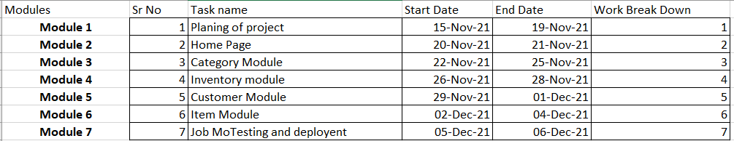

**Task 3 - Design mock-ups**

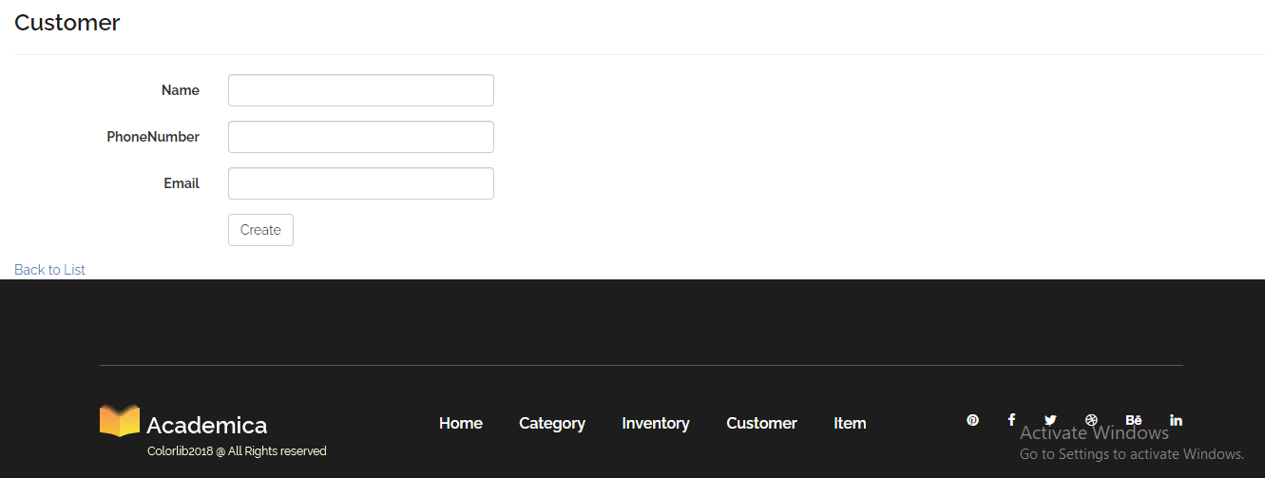

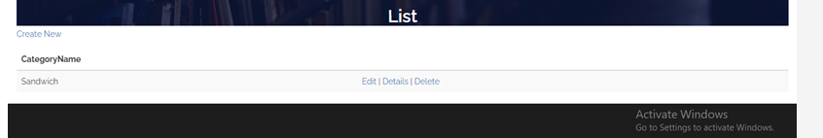

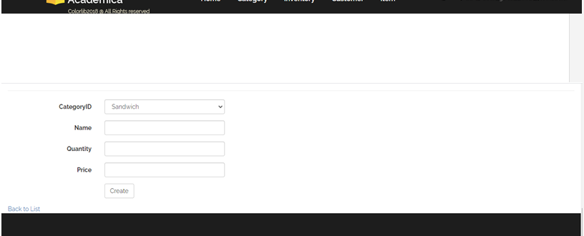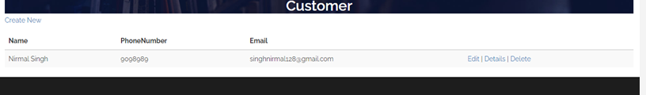**Colour Schemes: All modules will have black, blue, white and yellow combination.**

## Task 5- usability testing

**Create your own task**

1. **Task 1- customer form fill**
2. **Task 2 – Add new Categories**
3. **Task 3 – Update categories**
4. **Task 4 - update customers**
5. **Task 5 – delete customers**

**User details -**

**User 1 – Male 21yr old , student, good computing skills**

**user 2 – Female 19 yr Old, Student, nice nature**

**user 3 – Female 25 yr old, Professional worker**

**Result Summary**

|  |  |  |  |  |  |
| --- | --- | --- | --- | --- | --- |
| User | Task 1 | Task 2 | Task 3 | Task 4 | Task 5 |
| User 1 | **Completed** | **Not completed** | **Completed** | **Completed** | **Completed** |
| User 2 | **On submit next page opened** | **Categories Added** | **Updated worked** | **Customer Updated** | **Delete worked** |
| User 3 | **Next page opened** | **Categories Added** | **Updated task worked** | **Updating work** | **Deleted** |

**Task 6 - Meet with your client**

Client Meeting:

|  |
| --- |
| Meeting Details |
| * Date and time: 25-Oct-2021 * Location: New Zealand |
| Attendees: Jatin and Roban |
| Agenda: Discussion of Software of Canteen management system |
| Discussion (Important Points): He wants neat and clean software which will work effectively |
| My To Dos (Actions): Firstly I have to make the mockups of the application. Then Starting the application after the next meeting. |
| Questions requiring Follow- Up: Discussion of the mock ups |
| Comments: Jatin is good person and he described regarding software very wisely. |
| Next meeting  Date and Time: 1- Nov-2021 1:00 Pm  Location: New Zealand  Agenda: Showing the mock ups to the client and discussion about further development. |

**Appendix 3**

**Client Review Form**

My developer’s name: Robanpreet

This form is intended to let you review the communication skills of your developer for this assignment. Your review will partly count towards their final mark. Do not take into account technical skills.

# Grading scale

You must grade your developer for each item listed in the tables below. 1 being the lowest, 5 the highest.

|  |  |  |  |  |
| --- | --- | --- | --- | --- |
| **1** | **2** | **3** | **4** | **5** |
| Strongly disagree | Disagree | Ok | Agree | Strongly agree |

# Review your developer

|  |  |  |
| --- | --- | --- |
| **Item** | **Grade** | **Comment** |
| Communicated clearly and effectively | 3 |  |
| Kept you informed of the progress | 2 |  |
| Met timelines | 3 |  |
| Responded promptly to problems | 5 |  |
| Met overall project objectives | 4 |  |
| Was open to new ideas and suggestions | 1 |  |
| Was easy to work with | 2 |  |

Comments

Provide any extra comments on your developer’s communication skills and professionalism.

## Signed by Client

|  |  |
| --- | --- |
| **Signature: Jatin** | **Date: 14-nov-2021** |
| **Name: Robanpreet** | **Title: Canteen Management System** |
| **Contact details (email/Tel):** | |

**Task 8 - Software development life cycle stages**

**Planning :-**

1. Define the problem and scope of existing system.
2. Overview the new system and determine its objectives.
3. Confirm project feasibility and produce the project Schedule.
4. During this phase, threats, constraints, integration and security of system are also considered.
5. A feasibility report for the entire project is created at the end of this phase.

SDLC helped lot in planning this file according to as I defined overview of the project and defined the problem of the client and provide him a solution .

**Requirement :-**

1. Gather, analyse, and validate the information.
2. Define the requirements and prototypes for new system.
3. Evaluate the alternatives and prioritize the requirements.
4. Examine the information needs of end-user and enhances the system goal.
5. A Software Requirement Specification (SRS) document, which specifies the software, hardware, functional, and network requirements of the system is prepared at the end of this phase.

In requirement gathering SDLC helped a lot again in this from gathering the information to defining the requirements and then examining the Goal of the Website

**Software Design and prototyping:-**

1. Includes the design of application, network, databases, user interfaces, and system interfaces.
2. Transform the SRS document into logical structure, which contains detailed and complete set of specifications that can be implemented in a programming language.
3. Create a contingency, training, maintenance, and operation plan.
4. Review the proposed design. Ensure that the final design must meet the requirements stated in SRS document.
5. Finally, prepare a design document which will be used during next phases.

**Software Development:**

1. Implement the design into source code through coding.
2. Combine all the modules together into training environment that detects errors and defects.
3. A test report which contains errors is prepared through test plan that includes test related tasks such as test case generation, testing criteria, and resource allocation for testing.
4. Integrate the information system into its environment and install the new system.

**Testing:**

1. Include all the activities such as phone support or physical on-site support for users that is required once the system is installing.
2. Implement the changes that software might undergo over a period of time, or implement any new requirements after the software is deployed at the customer location.
3. It also includes handling the residual errors and resolve any issues that may exist in the system even after the testing phase.
4. Maintenance and support may be needed for a longer time for large systems and for a short time for smaller systems.

**Task 9- Project management**

The project evaluation process uses systemic analysis to gather data and reveal the effectiveness and efficiency of your management. This crucial exercise keeps projects on track and informs stakeholders of progress.

This Project Success

Hard work is a key to this successful project and only reason of this project success is deep research and development done by me as the reason this project completed on time because we learn lot from research and development

Lesson Learned from this Project

Use of Research and development is the biggest lesson I learned from this project and another is how to gather requirements from client and then making mockups and then show to them and start working on coding and then show and this process work so on .

Weakness

I found working without team as my weakness as I faced many problems in designing part and then I realize that I need to work alone as I was expecting that some one will do designing part.

Improve Product Quality

Every aspect of the project is measured to determine if it’s proceeding as planned, and if not, inform how project parts be improved. Basically, you’re asking the project a series of questions designed to discover what is working, what can be improved and whether the project is in fact useful. Tools like project dashboards and trackers help in the evaluation process by making key data readily available.

The project evaluation process has been around as long as there have been projects to evaluate. But when it comes to the science of project management, project evaluation can be broken down into three main types: pre-project evaluation, on-going evaluation and post-project evaluation. So, let’s look at the project evaluation process, what it entails and how you can improve your technique.